EXPERIMENT 4 B
EXPLORATORY DATA ANALYSIS (EDA) – DATA INSPECTION, FILTERING, STATISTICAL ANALYSIS AND CORRELATION

Aim
To perform data inspection, filtering, grouping, aggregation, descriptive statistical analysis, and correlation analysis using Pandas and visualize the results using Matplotlib.

Algorithm 1 – Dataset Inspection
Step 1 Import Pandas.
Step 2 Load dataset.
Step 3 Display dataset.
Step 4 Check dimensions.
Step 5 Display data types.

Program 1 – Display Dataset
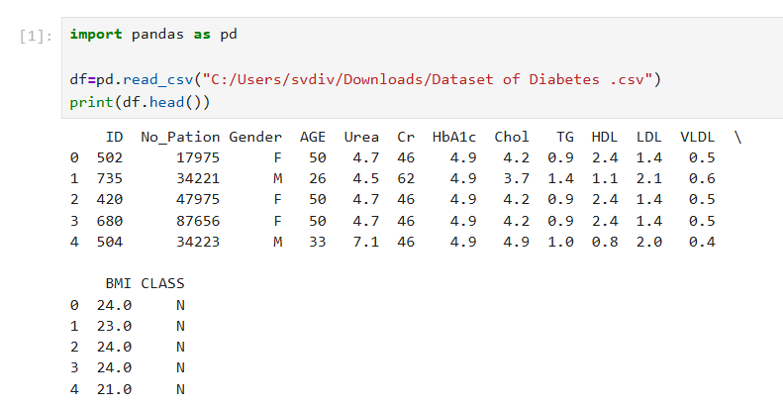

Program 2 – Shape of Dataset
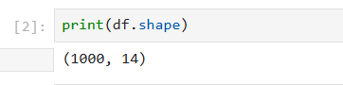

Program 3 – Data Types
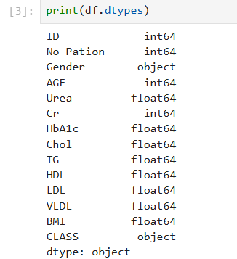
Algorithm 2 – Filtering Data
Step 1 Specify condition.
Step 2 Apply filter.
Step 3 Display records.

Program 4 – Patients Above Age 50
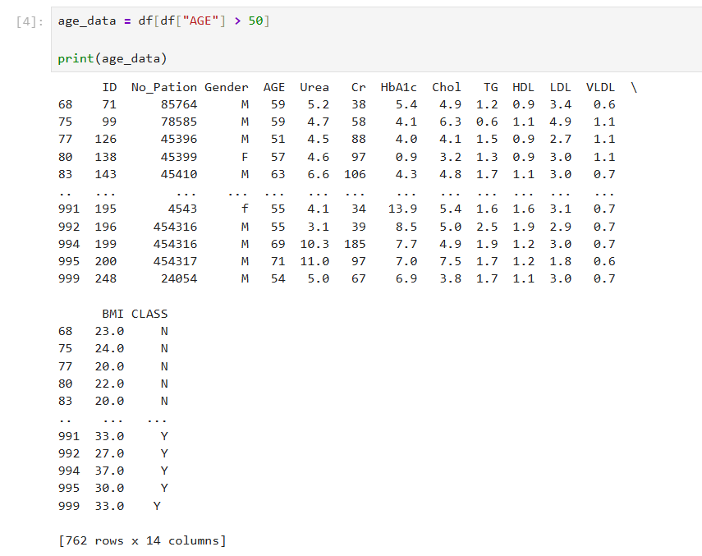
Program 5 – Patients with High HbA1c
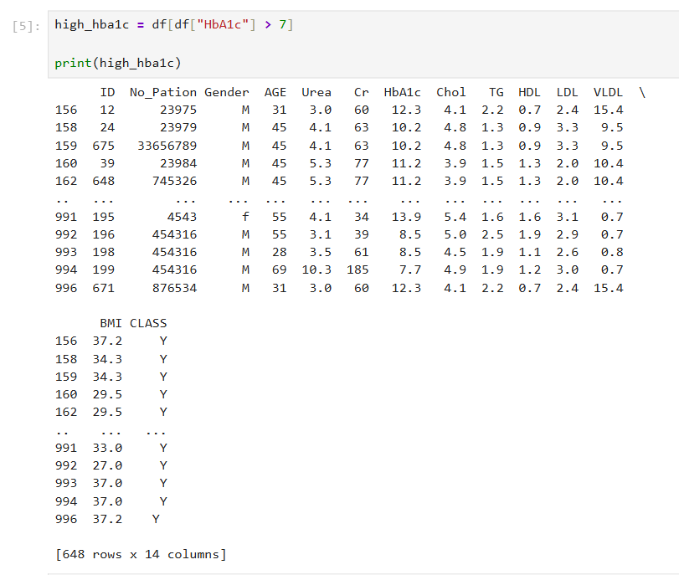
Algorithm 3 – Sorting Data
Step 1 Select column.
Step 2 Apply sort_values().
Step 3 Display result.
Program 6 – Sort by HbA1c
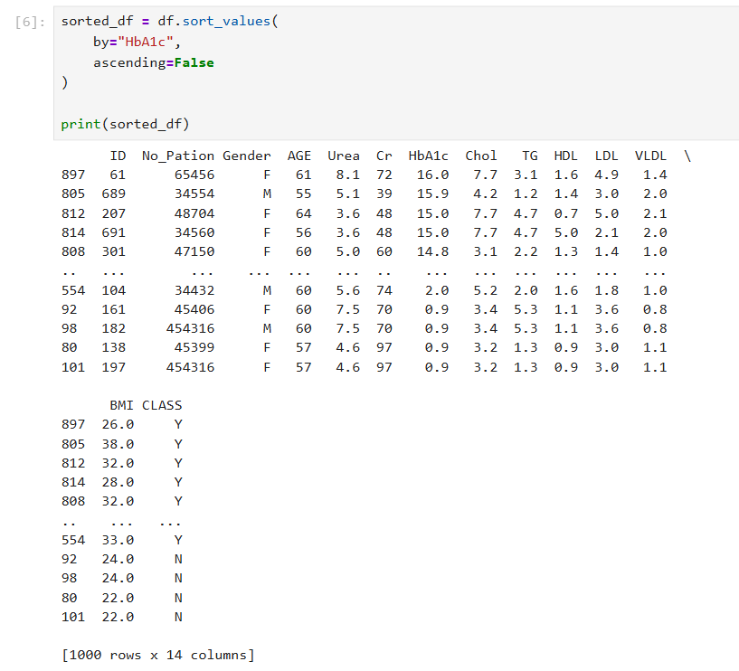
Visualization – HbA1c Analysis
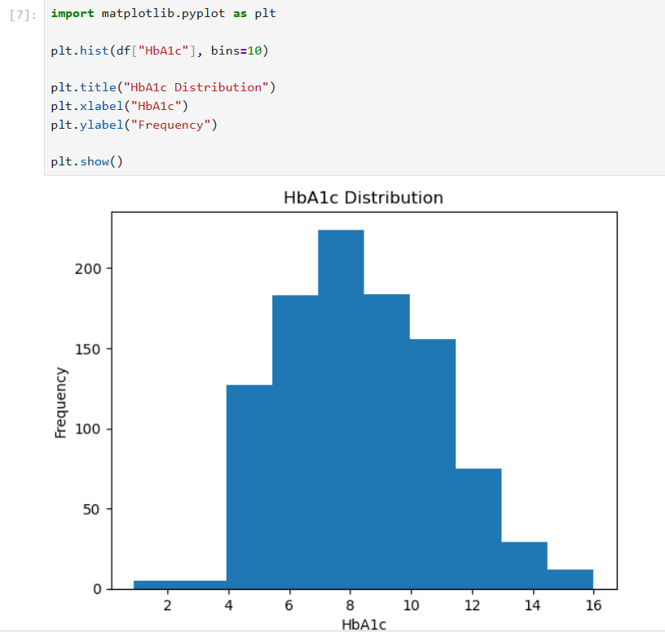
Algorithm 4 – Statistical Analysis
Step 1 Select numerical column.
Step 2 Calculate Mean.
Step 3 Calculate Median.
Step 4 Calculate Mode.
Step 5 Calculate Standard Deviation.
Program 7 – BMI Statistics
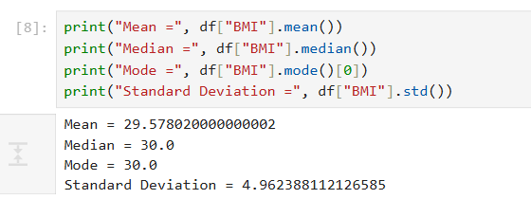

Program 8 – Descriptive Statistics
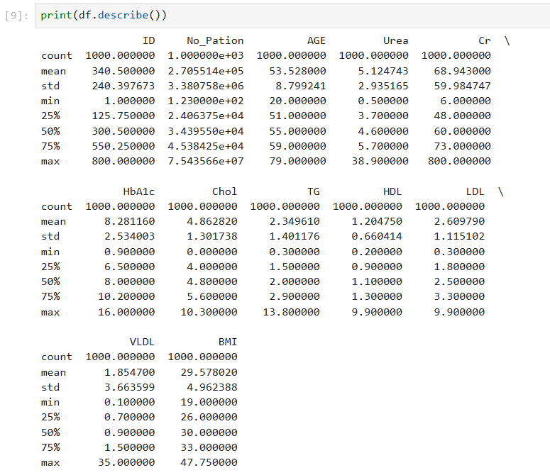

Algorithm 5 – Grouping and Aggregation
Step 1 Select categorical column.
Step 2 Apply groupby().
Step 3 Calculate average values.
Step 4 Display result.

Program 9 – Average Age by Gender
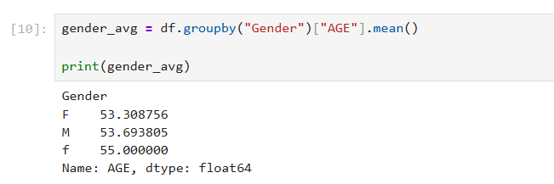

Visualization – Gender-wise Average Age
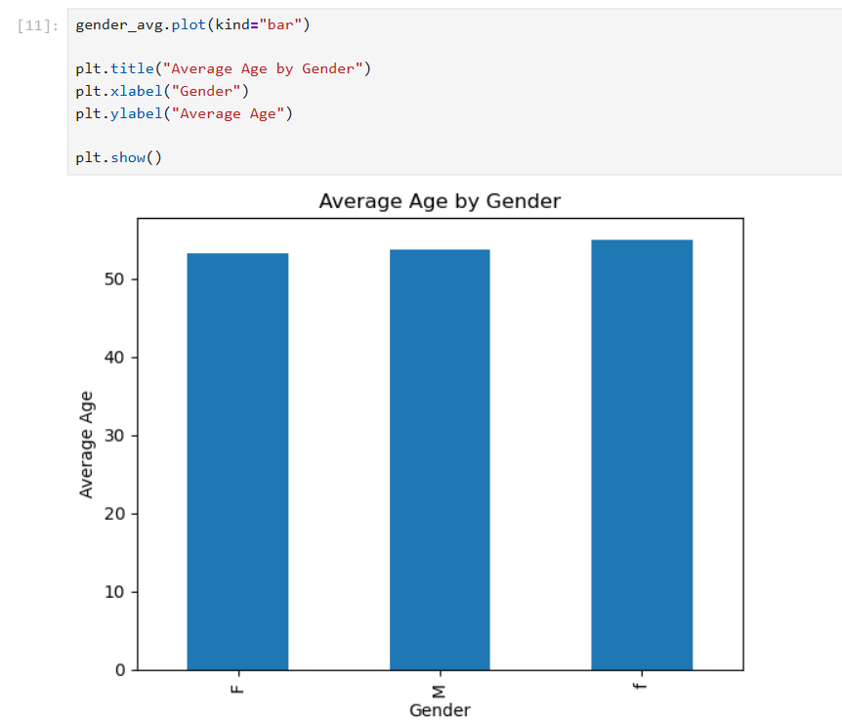

Algorithm 6 – Correlation Analysis
Step 1 Select numerical columns.
Step 2 Apply corr().
Step 3 Display correlation values.

Program 10 – Correlation - Correlation Visualization
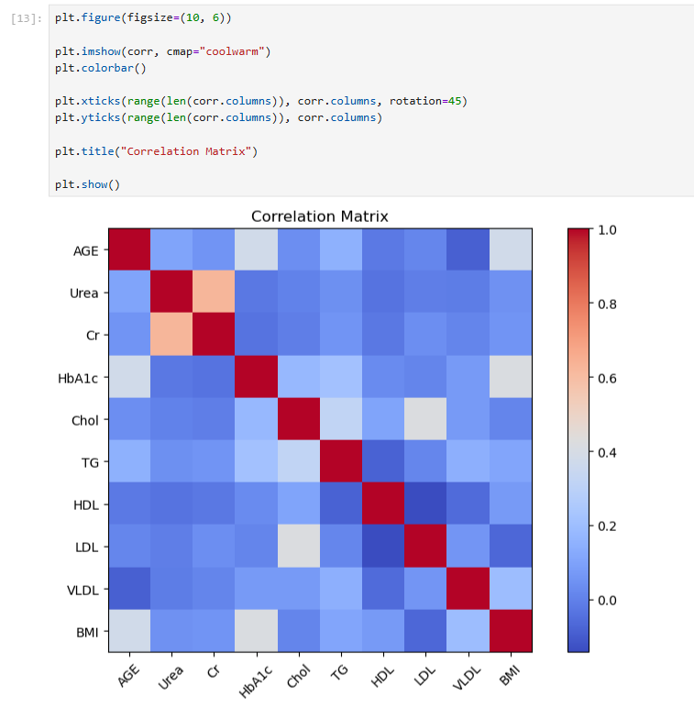

Result
Thus, data inspection, filtering, sorting, descriptive statistical analysis, grouping, aggregation, and correlation analysis were successfully performed using Pandas. The analytical results were visualized and interpreted successfully.

